10.78: a) The kinetic energy of the ball when it leaves the tract (when it is still rolling without slipping) is 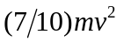and this must be the work done by gravity, W = mgh, so 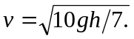The ball is in the air for a time 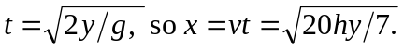
b) The answer does not depend on g, so the result should be the same on the moon.
c) The presence of rolling friction would decrease the distance.
d) For the dollar coin, modeled as a uniform disc, 